1. Note | ※Please delete this page upon submission
▪ Please refer to “Recruitment of Accelerators for 2024 Global Market Expansion Program” and this “Note” to complete the application form. Responsibility for ignorance of the contents of the said documents or disadvantages suffered attributable to the applicants rests with the applicants.

▪ Once an accelerator is found to have submitted its program plan with unidentified and/or false information, it may suffer from disadvantages: minus points, cancellation of the selection.

▪ You may suffer from disadvantages if you don’t follow the format or omit some of the documents. You may be excluded from the evaluation process if you submit unfaithful program plan.

▪ Titles in the format already written are not editable. However, feel free to add tables, lists, lines, etc, in the fields with ‘□’, ‘○’, ‘-’, ‘*’

▪ Any contents of the submitted documents are not editable after the deadline.

▪ If the contents of the submitted documents such as letters and images are illegible or invisible, the applicant may have a disadvantage in the evaluation process.
2. Submission of the Documents
▪ Deadline : No later than 15:00(KST), March 22th (Fri), 2024

▪ Documents : ① Program Plan, ② Program Budget, ③ Business Registration Certificate, ④ Curriculum Vitae of the Dedicated Personnel,
⑤ Promotional Materials of the Accelerator (Brochure, PPT, Promotional Videos, etc.)

▪ Submission : Please send the documents to the email of the Management Agency.
Region | Sector | Name of  the Management Agency | Email
North  America | Edu-tech, Digital contents | Korea Edutech Industry Association | geou3@ketia.kr
 | Information and Communication, AI, Big data | Korea Entrepreneurship Foundation | global@koef.or.kr
Europe | Food-tech, AgTech, green bio | Korea Agriculture Technology  Promotion Agency | jkkim100@koat.or.kr
 | Smart city | Smart City Association | global@smartcity.or.kr
Asia | Sport convergence, healthcare | Korea Sports Promotion Foundation | global_ac@kspo.or.kr
 | Logistics, distribution, smart logistics | Korea Integrated Logistics Association | rc06@koila.or.kr
 | Fintech | Fintech Center Korea | goglobal@fintech.or.kr
Africa | Climate tech | The Korea-Africa Foundation | ecd@k-af.or.kr

「2024 Global Market Expansion Program」
Program Plan of the Accelerator

Month 2024

Name of the Accelerator
Name of the Representative | (Seal)
Writer | (Seal)

2024 Global Market Expansion Program
Program Plan of the Accelerator (Summarized)
1 |  | Overview
Name of the Accelerator  (Leading AC) |  |  |  |  |  | Name of the Representative
Establishment Date |  |  |  |  |  | Webpage
Category  (Select One) |  | No. | Region |  |  | Sector |  | V
 |  | 1 | North  America |  |  | Edu-tech, digital contents
 |  | 2 |  |  |  | ICT, AI, Big data
 |  | 3 | Europe |  |  | Food-tech, AgTech, Green bio
 |  | 4 |  |  |  | Smart city
 |  | 5 | Asia |  |  | Sport convergence, Healthcare
 |  | 6 |  |  |  | Logistics, Distribution, Smart logistics
 |  | 7 |  |  |  | Fintech
 |  | 8 | Africa |  |  | Climate Tech
Specialized Sector
Funding |  | □ Yes, we can provide Funding. |  |  |  |  | □ No, we can’t.
Characteristics and Major Achievements of the Accelerator
Staff Members |  | Name |  | Position |  | Phone No./Email | Dedicated Personnel (Y/N)
2 |  | Operation of Global Market Expansion Program
Program KPIs
Program Operating Costs |  | KRW
Identification, Evaluation and Selection of the Startups |  | Plans for Finding out Startups
 |  | Plans for Evaluator Team, Evaluation, and Selection
Program Operation Plan in detail for Program | Ⅰ | Period
 |  | KPIs
 |  | Contents
 | Ⅱ | Period
 |  | KPIs
 |  | Contents
 | Ⅲ | Period
 |  | KPIs
 |  | Contents
Major Network of the Accelerator

2024 Global Market Expansion Program
Program Plan of the Accelerator

※ Please be clear and specific in completing the form within 30 pages.
※ Feel free to add more items while completing the format.

1. Overview of the Accelerator

1) Current Status and Characteristics of the Accelerator
※ Please complete the format, including establishment year, career of the representative, company history, infrastructure, amount of raised fund, etc, so that the accelerator can be comprehensively introduced.

<Accelerator History>
0000. 0 …  0000. 0 …  0000. 0 … | (Exterior picture of the company)
 | (Exterior picture of the company)

□ …

◦ …

- …

2) Current Status of Program Operation for the Last Three Years (Startup Programs)
※ Please write about current status of startup program operation for the last three years, number of startups by year.

□ …

◦ …

- …

3) Best Practices of accelerating programs
※ Please elaborate on best cases of accelerating programs.

□ …

◦ …

- …

4) Others
※ Please include press release in foreign newspapers, award records, etc., to introduce your company.

□ …

◦ …

- …

2. Program Operation Plan

1) Program Operation Goals
※ Please propose quantitative and qualitative goals.
* Whether the goals are achieved to be evaluated upon the end of the program.
□ …

◦ …

- …

2) Current Status and Career of the Staff Members
※ Please elaborate on the team and staff members who will operate Global Market Expansion Program, major careers of the dedicated personnel, etc.
□ …

◦ …

- …

3) General Support for Startups, including office space
※ Please expound on how you can support Korean startups during Program II, in the target country, such as office space, meeting rooms, etc., for their local business.
□ …

◦ …

- …

4) Program Operation Plan in Detail for Program
※ Please elaborate on the plan by week, month, topic and module.
※ Please prepare your own modules for Program, referring to the table below. However, make sure that modules marked with “★” in the table must be included in your program plan.

< Contents of the Program (Draft) >
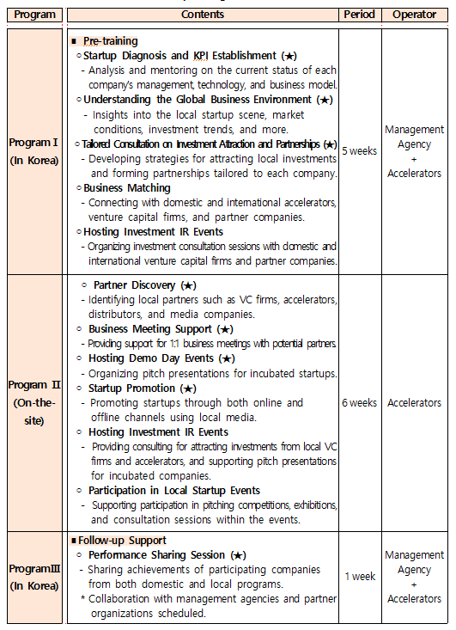

4-1) Ⅰ (In Korea)
□ …

◦ …
- …

4-2) Ⅱ (On-the- Site)

□ …

◦ …

- …

4-3) Ⅲ (In Korea)

□ …

◦ …

- …

3. Selection and Management

1) Plans for Identification of the Startups
※ Please elaborate on the plans to find out excellent Korean startups.
□ …

◦ …

- …
2) Plans for Organization of the Evaluator Team
※ Please state the names, affiliations, positions, expertise, etc, of the Evaluator Team members. They shall be capable of comprehensively evaluating marketability and technology of the startups.
□ …

◦ …

- …

3) Criteria for Startup Evaluation
※ Please state criteria and details thereof to apply during the evaluation: document screening and presentation evaluation.
□ …

◦ …

- …
4) Plans for Supporting and Managing Startups
※ Please elaborate on how to provide complete support to startups from selection to the end of the program, how to measure the achievement of each startup, etc.

□ Plans for Management of the Achievements of the Startups

◦ …

- …

□ Plans for Follow-up Management of the Startups

◦ …
- …

□ Plans for funding
※ Please explain your plan for funding in excellent startups

□ …

◦ …

- …

4. Plans to Utilize the Network of the Accelerator

1) Current Status of the Accelerator`s Network
※ Please complete the table with affiliation, name, position, expertise, major career, so that we can understand whether the accelerator has dynamic and wide range of network with venture capitals, experts in the sectors, government agencies, large-scale enterprises, research institutes, universities, etc.

No. | Category | Sector | Affiliation | Position | Name | Major Career
1 | Technician | Bio | ooo company | Team Leader | Hong Kil-dong | ‧ Venture Capitalist, OO VC  ‧ Founded OO (2013)
2 | Technician | AI
... | Technician | Big data
... | Technician | Funding
... | Technician
... | Technician
15 | Technician
1 | Business Administration | Tax affairs
2 | Business Administration | Accounting
3 | Business Administration | Legal Affairs
... | Business Administration
... | Business Administration

2) Plans to Utilize the Network of the Accelerator
※ Please write on how to utilize the network of the accelerator during the program, such as matching between mentors and startups.
□ …

◦ …

- …

